Verilog Lab HDL

Assignment-1

Name- Aye Myat Thiri Khin

ID-20293

Exercise-1

Q: Directly run the module *helloWorld* in the online compiler.

Ans:

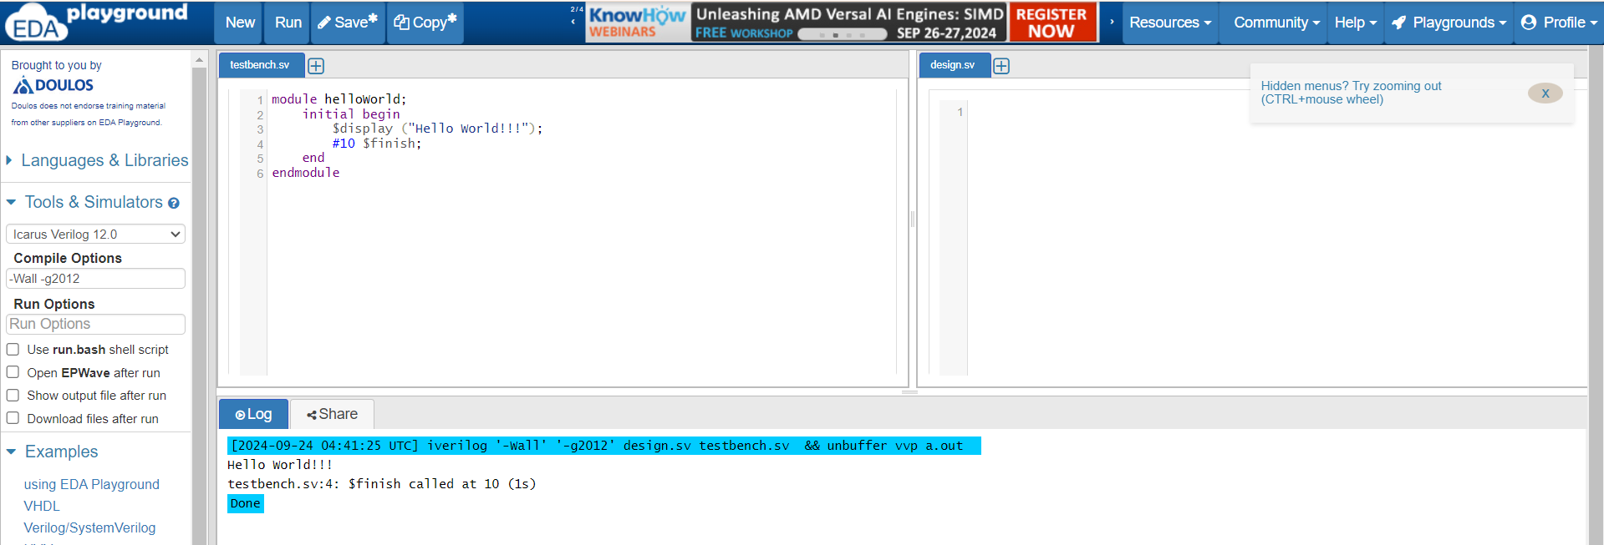

module helloWorld;

initial begin

$display ("Hello World!!!");

#10 $finish;

end

endmodule

Result Output :

[2024-09-24 04:41:25 UTC] iverilog '-Wall' '-g2012' design.sv testbench.sv && unbuffer vvp a.out   
Hello World!!!  
testbench.sv:4: $finish called at 10 (1s)  
Done

--------------------------------------------------------------------------------------------------Exercise-2

Q: Based on the module *gates*, draw the digital circuit schematic.

Ans:

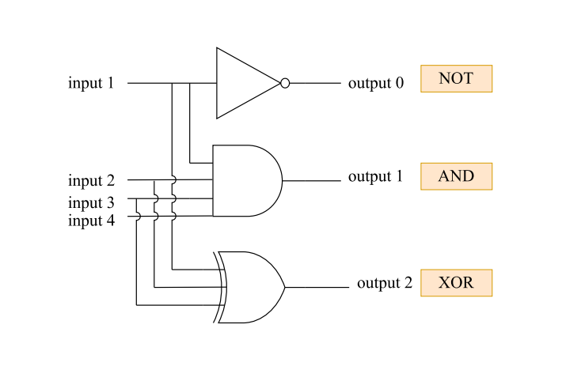

module gates();

wire out0, out1, out2;

reg in1, in2, in3, in4;

not U1(out0, in1);

and U2(out1, in1, in2, in3, in4);

xor U3(out2, in1, in2, in3);

endmodule

-------------------------Exercise-3

Q: Create the testbench first, and then simulate the design modules *oneBitFA1*, *oneBitFA2*.

Ans:

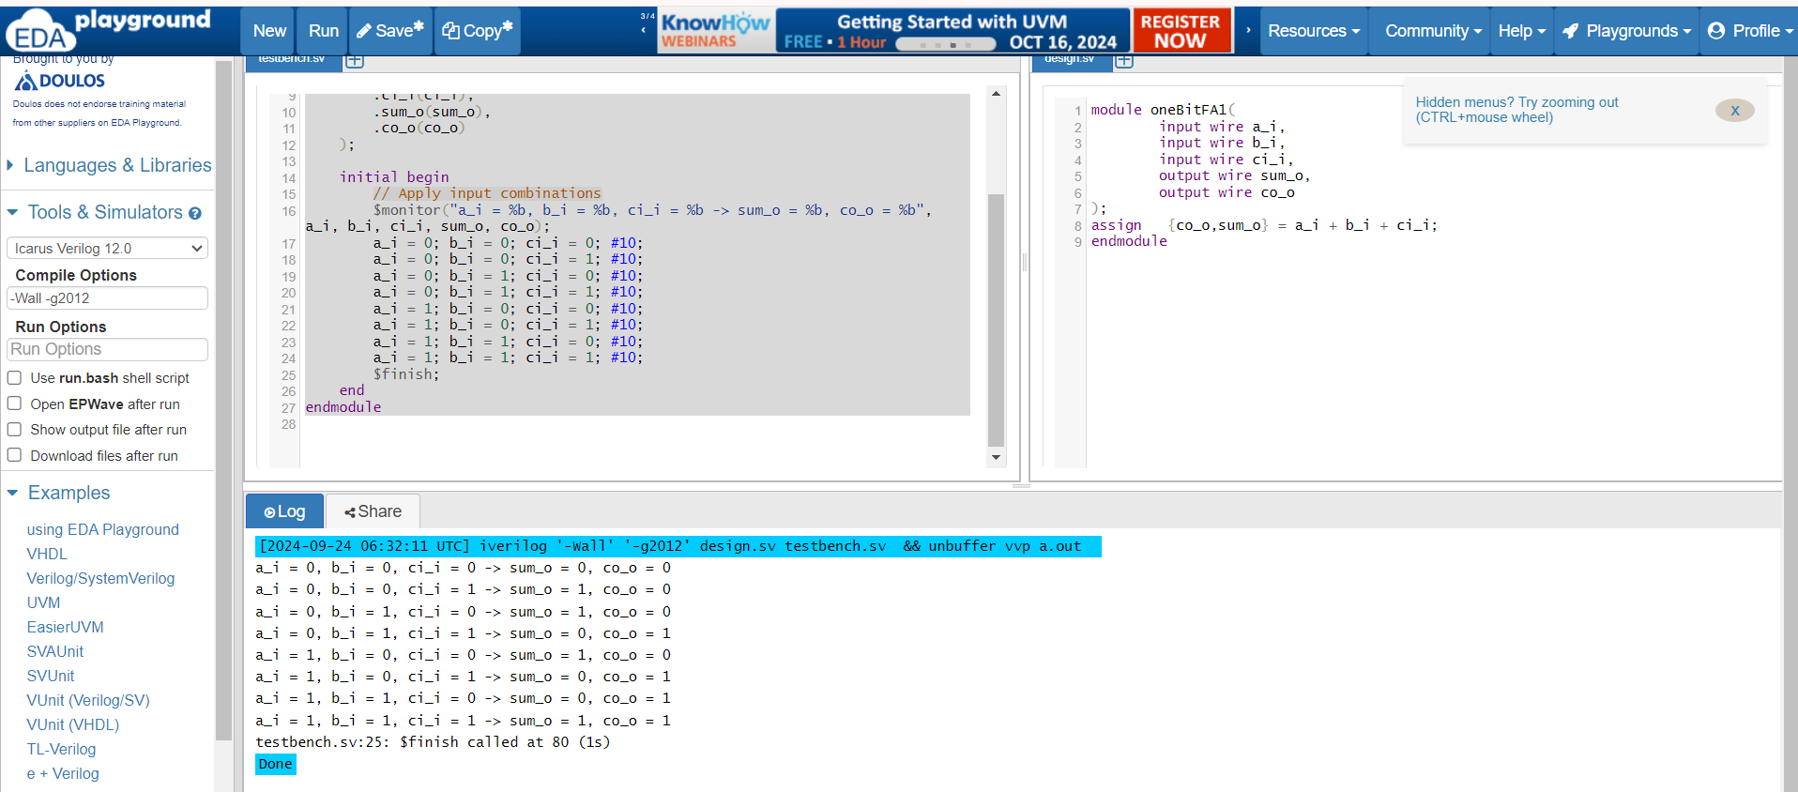

module testbench_oneBitFA1;

reg a_i, b_i, ci_i;

wire sum_o, co_o;

// Instantiate the oneBitFA1 module

oneBitFA1 uut (

.a_i(a_i),

.b_i(b_i),

.ci_i(ci_i),

.sum_o(sum_o),

.co_o(co_o)

);

initial begin

// Apply input combinations

$monitor("a_i = %b, b_i = %b, ci_i = %b -> sum_o = %b, co_o = %b", a_i, b_i, ci_i, sum_o, co_o);

a_i = 0; b_i = 0; ci_i = 0; #10;

a_i = 0; b_i = 0; ci_i = 1; #10;

a_i = 0; b_i = 1; ci_i = 0; #10;

a_i = 0; b_i = 1; ci_i = 1; #10;

a_i = 1; b_i = 0; ci_i = 0; #10;

a_i = 1; b_i = 0; ci_i = 1; #10;

a_i = 1; b_i = 1; ci_i = 0; #10;

a_i = 1; b_i = 1; ci_i = 1; #10;

$finish;

end

endmodule

Design:

module oneBitFA1(

input wire a_i,

input wire b_i,

input wire ci_i,

output wire sum_o,

output wire co_o

);

assign {co_o,sum_o} = a_i + b_i + ci_i;

endmodule

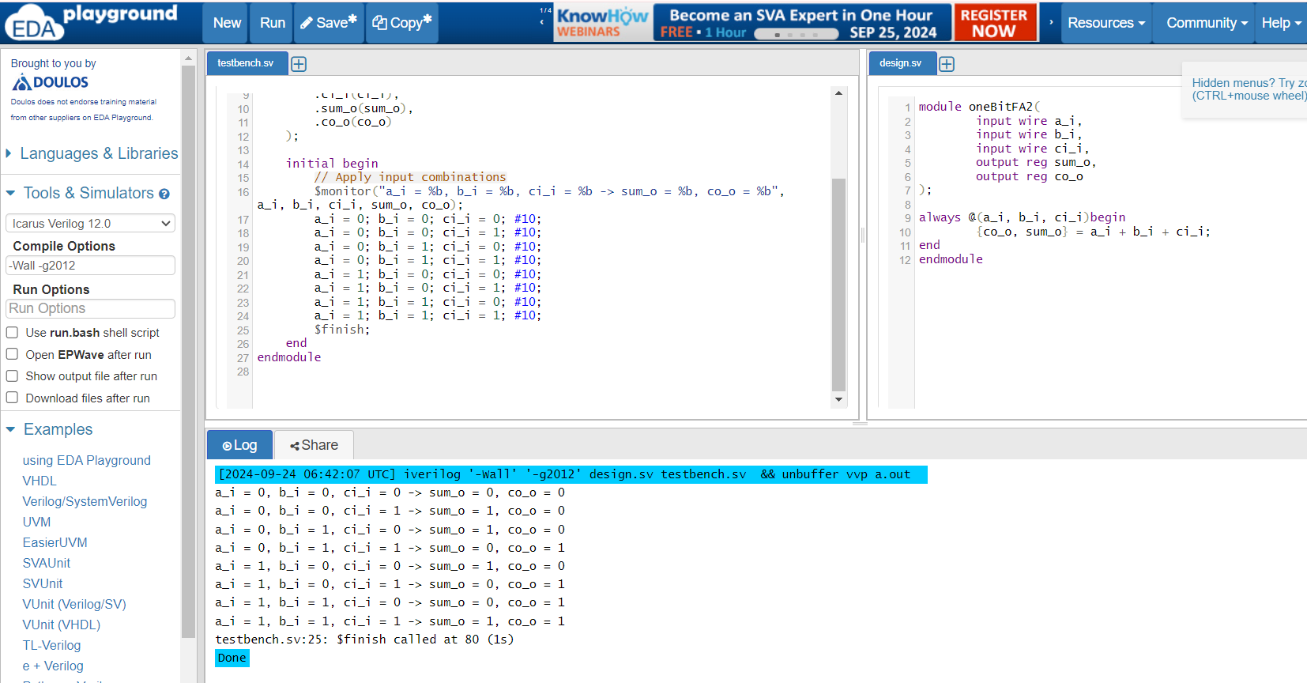

module testbench_oneBitFA2;

reg a_i, b_i, ci_i;

wire sum_o, co_o;

// Instantiate the oneBitFA2 module

oneBitFA2 uut (

.a_i(a_i),

.b_i(b_i),

.ci_i(ci_i),

.sum_o(sum_o),

.co_o(co_o)

);

initial begin

// Apply input combinations

$monitor("a_i = %b, b_i = %b, ci_i = %b -> sum_o = %b, co_o = %b", a_i, b_i, ci_i, sum_o, co_o);

a_i = 0; b_i = 0; ci_i = 0; #10;

a_i = 0; b_i = 0; ci_i = 1; #10;

a_i = 0; b_i = 1; ci_i = 0; #10;

a_i = 0; b_i = 1; ci_i = 1; #10;

a_i = 1; b_i = 0; ci_i = 0; #10;

a_i = 1; b_i = 0; ci_i = 1; #10;

a_i = 1; b_i = 1; ci_i = 0; #10;

a_i = 1; b_i = 1; ci_i = 1; #10;

$finish;

end

endmodule

Design:

module oneBitFA2(

input wire a_i,

input wire b_i,

input wire ci_i,

output reg sum_o,

output reg co_o

);

always @(a_i, b_i, ci_i)begin  
{co_o, sum_o} = a_i + b_i + ci_i;

end

endmodule